­

***Student ID : 1352373 Student Name : SUFIYAN***

***Student ID : 1343502 Student Name : M.AMMAR***

***Student ID : 1352615 Student Name : UZAIR KHAN***









***SUFIYAN***

***M.AMMAR***

***UZAIR KHAN***

Has successfully completed Course of Study

CERTIFICATE OF COMPLETION

Signature

Date

E Project: LibertyElectronics

LibertyElectronics

|  |  |  |
| --- | --- | --- |
| Faculty. | Miss Aeliya | |
| Batch. | PR2-202111E1 | |
| Serial No. | Enrollment Number | Student Name |
| 1. | *1352373* | *SUFIYAN* |
| 2. | *1343502* | *M.AMMAR* |
| 3. | *1352615* | *UZAIR KHAN* |

E Project: LibertyElectronics

# ACKNOWLEDGEMENT

The first, we would like to express my special thanks of gratitude to my teacher Miss Aeliya who helped us a lot in finalizing this project within the limited time frame, valuable counselling and assistance for the accomplishment of this project.

Secondly, we would also like to thank the e Project team at Aptech Head Office, who gave us the golden opportunity to do this wonderful project about LibertyElectronics.

Thirdly, we also thank the e Project team some of the benefits are as under:

* Re-enforcement of skills happens in the experiential learning process.
* A mentor, ensuring that we do not get drifted, constantly guides us.
* It gives us a lot of confidence to face an interview as we have worked on a project. We can explain virtually everything on the subject we have learnt.

1

E Project: LibertyElectronics

# SYNOPSIS

Follow the strong development of the internet, technology watches and the growing watch market, every business needs a website design to display products on the internet.

The following electronic product are designed with many different designs, suitable for all styles and preferences, which are the most special suggestions from Liberty Electronics.

Attached are the introductions hidden behind the watch gift from the gift you want to send to your lover, colleagues or loved ones.

So,Liberty Electronicsshares the best product images through the website for everyone to know.

However, purchases are not made directly on the website

2

E Project: LibertyElectronics

# PROBLEM DEFINITION

Liberty Electronicsis into business of manufacturing and selling electronics. They have been advertising about their Led Tv and Washing Machine through newspapers, pamphlets, television. Now with changing times, they have decided to go online as customers today use Internet extensively. They have planned for a website with complete details about their washing machine and electronics

So, we solved many particular queries as followed:

* How the sitemap possibly looks alike?
* What information should be displayed on each page?
* How to put every comment is friendly?
* How to give users the best experience when using the website?
* How to let the website properly functioning along with the system requirement?
* Will the user be able to contact withLiberty Electronics company for advice?

3

E Project: LibertyElectronics

# CUSTOMER REQUIREMENT SPECIFICATION (CRS)

The Web site is to be created based on the following requirements.

1. The Home Page should be created making use of sections with a suitable logo
2. The site should display a menu which will contain the options for brief introduction about the various products available, location of the shop and any other information if required.
3. The information should be categorized according to the brand names of the products like if a User wants to see only Samsung products then he click on a Link/button/menu etc. and he will see only That Brand products.
4. When a user selects any particular brand, a list of products for that brand will be displayed
5. A brief summary of features of individual products should be displayed on the Web Page along with the product but detailed Features should be stored in Individual Word documents which can be downloaded or viewed by the User who wishes to see the same.
6. The user should also be able to compare the various products of different as well as similar brands.
7. There should be a “Contact Us” page which will have the Address of the Company which is as follows and the mail address which when clicked will invoke the local mail client from where they can send an email.

4

E Project: LibertyElectronics

# SCOPE OF THE WORK (IN BRIEF)

The website is to be developed for the Windows Platform using HTML5, JavaScript and Geolocation. The site should work well in all leading browsers including Chrome, IE, Firefox etc...

Homepage show Top best sell items, big sale, collection, new shop... Every content direct to relative content.

5

E Project: LibertyElectronics

# AGGREGATED SITEMAP

## HOME

(0.Welcome.html)

## CATEGORIES

(1.Index.html)

E Project:

LibertyElectronics



# WIREFRAMES

1. Main Layout

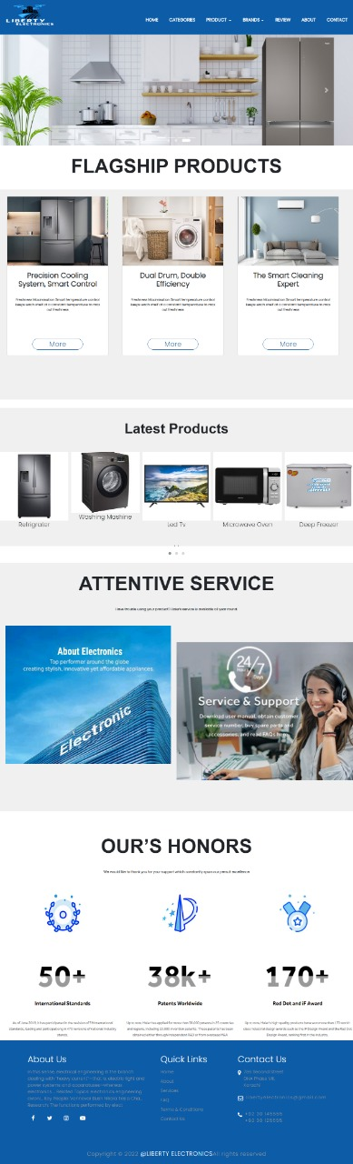

3

eProject: Aura Watches

1. Home Page (1.Index.html)



4

eProject: Aura Watches

E Project: LibertyElectronics

1. Product Page (2.Products.html)

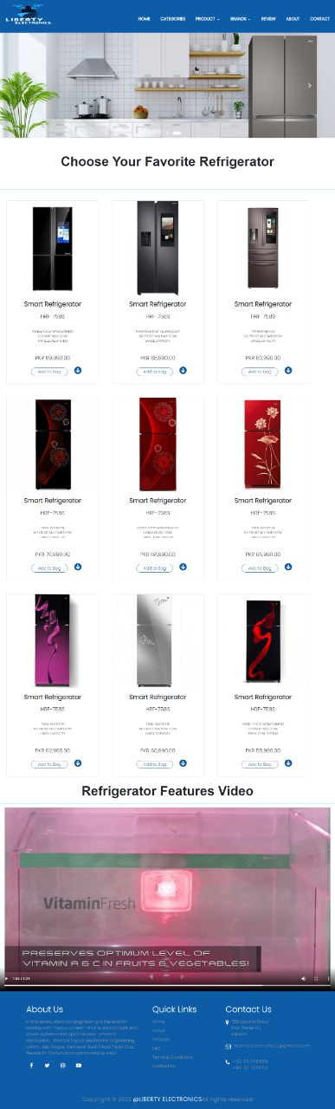

6

E Project: LibertyElectronics

1. Product Line-Up
   * Product Line-Up 1: Quazts Clock (2.Products.html)
     + Quazts Clock 1 (*Product-Q-1.html*)
     + Quazts Clock 2 (*Product-Q-2.html*)
     + Quazts Clock 3 (*Product-Q-3.html*)
     + Quazts Clock 4 (*Product-Q-4.html*)
   * Product Line-Up 2: Eco-Drive Clock(*2.Products.html*)
     + Eco-Drive Clock 1 (*Product-W-1.html*)
     + Eco-Drive Clock 2 (*Product-W-2.html*)
     + Eco-Drive Clock 3 (*Product-W-3.html*)
     + Eco-Drive Clock 4 (*Product-W-4.html*)
   * Product Line-Up 3: Automatic Clock (*2.Products.html*)
     + Automatic Clock 1 (*Product-A-1.html*)
     + Automatic Clock 2 (*Product-A-2.html*)
     + Automatic Clock 3 (*Product-A-3.html*)
     + Automatic Clock 4 (*Product-A-4.html*)

Project: Aura Watches

8

E Project: LibertyElectronics

Technology Page (3.Technology.html)



9

1. Store Locator Page (4.Store_Locator.html)

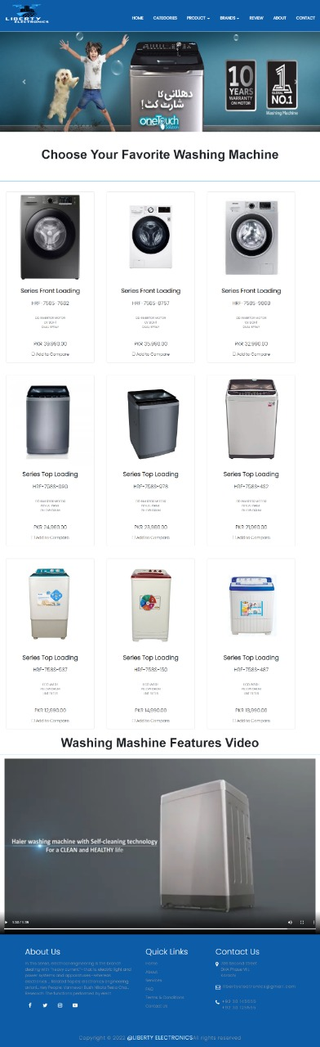

10

eProject: Aura Watches

1. Support Page (5.Support.html)
2. Register Page (6.Register.html)

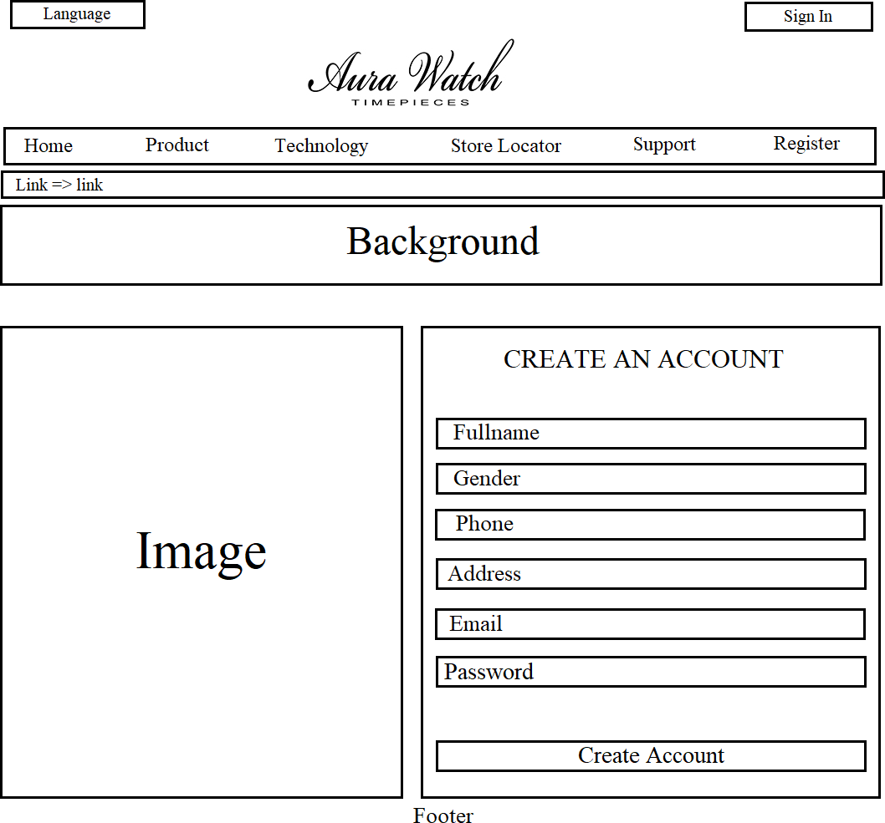

12

E Project:LibertyElectronics

TASK SHEET REVIEW 2

|  |  |  |  |  |  |  |
| --- | --- | --- | --- | --- | --- | --- |
| E Projects  Breakpoints | | Project title | Date of Preparation of Activity Plan | | | |
| No | Task | ***Liberty Electronics*** | Actual | Actual | Team-mate | Status |
| Start Date | Days | Names |
| 1 | Build Home | DD/MM/YY | 1 | Student-1 | Complete |
| Page |
| 2 | Build Product Page And  Product Line-Up Pages | DD/MM/YY | 1 | Student-2 | Complete |
| 3 | Build | DD/MM/YY | 1 | Student-3 | Complete |
| Technology,  Support, Store Locator, Register |
| Pages |
| 4 | Build Price Page | DD/MM/YY | 7 | Student-4 | Drop Out |
| 5 | Begin Code  JavaScript For the Home Page | DD/MM/YY | 1 | Student-1 | Complete |
| 6 | Begin Code | DD/MM/YY | 1 | Student-2 | Complete |
| JavaScript For the Product  Page and Product Line-Up |
| Pages |
| 7 | Begin Code | DD/MM/YY | 1 | Student-3 | Complete |
| JavaScript For the Technology,  Support, Store Locator, Register |
| Pages |

13

E Project: LibertyElectronics

|  |  |  |  |  |  |  |
| --- | --- | --- | --- | --- | --- | --- |
| 8 | Begin Code Support for Browsers |  | DD/MM/YY | 1 | Student-1, Student-3 | Complete |
| 9 | Check Progress And Assign New Tasks | DD/MM/YY | 1 | Student-1 | Complete |

14

E Project: LibertyElectronics

# TASK SHEET REVIEW 3

|  |  |  |  |  |  |  |
| --- | --- | --- | --- | --- | --- | --- |
| Project Ref. No.: eP/Advertisement Portal Management  System/01 | | Project title | Date of Preparation of Activity Plan | | | |
| No | Task |  | Actual | Actual | Team-mate | Status |
|  | Start Date | Days | Names |
|  | Check color |  |  |  |  |  |
| 1 | format, size,  javascript, |  | DD/MM/YY | 2 | Student-3 | Complete |
|  | responsive in the |  |  |  |  |  |
|  | Home page |  |  |  |  |  |
|  | Check color |  |  |  |  |  |
| 2 | format, size,  javascript, responsive in |  | DD/MM/YY | 2 | Student-2 | Complete |
|  | Product page and |  |  |  |  |  |
|  | Product Line-up |  |  |  |  |  |
|  | Check color  format, size, javascript, | Aura Watch |  |  | Student-1 |  |
| 3 | responsive in  Technology, |  | DD/MM/YY | 2 |  | Complete |
|  | Support, Store |  |  |  |  |  |
|  | Locator, Register |  |  |  |  |  |
|  | page |  |  |  |  |  |
| 4 | Write a developer guide |  | DD/MM/YY | 2 | Student-2 | Complete |
| 5 | Write user |
| manuals |  |  |  |  |  |
| 6 | Overall inspection of the |  | DD/MM/YY | 2 | Student-2, Student-1, Student-3 | Complete |
|  | project |  |  |  |  |

15

***Thankyou.***

16